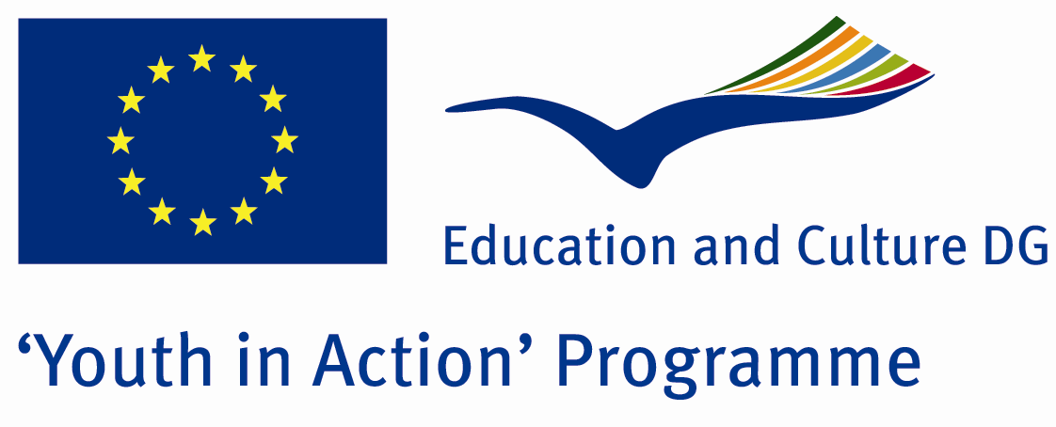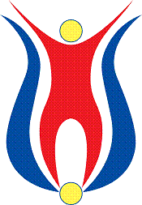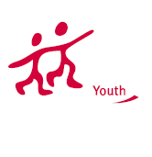

Action 4.3
Project Summary;

This project will be realized by young leaders and youngsters who come from different countries. We aim that we provide our guests to learn more information about the drugs and drugs effect in human life. While the number of recent drug-using young people, ages decreases. We investigating why the young people drawn to this kind of bad habbits and how to give up this.

Project Title; White End
Date and Venue ; 04-10 February 2012 Turkey
Place: Aydın

Target Group ; Municipalities, City Councils and Non-Governmental organizations,
youth groups,culture and art groups,e.t.c

Participants ; 5 people from each country (over 18 -25 ). Totally 8 countries.

Conditions ; Accommodation, board and programme costs will be financed through European Commission Youth in Action Programme . Travel costs will be reimbursed in 70% (APEX Tarrifs). Organizations from all 27 EU member countries plus Liechtenstein , Norway and Iceland are eligible to take part.

Working language: English

Organisator group: Groupzeybek

How to apply: If you are interested, please send your Part III forms to
by e-mail please (in word file). Scan Part3 format is enough for application.(Fulfilled Part III which you can find in the attachment, of course signed and stamped) ..

Contact e-mail: groupzeybek@gmail.com

